Visualisation COSC 6344

Assignment – 2

Task -1

1. The files sample.cpp, Geometry.cpp and Skeleton.h are modified as per the instructions given.
2. The data files(.ply files containing the values of the figures-direct_field1, distance field etc) are pasted into /models folder in the place of previously present files.
3. The selection drop down menu is modified in the panel with the new files so that the user can select them from the interface.

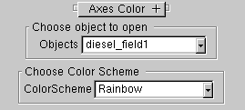

Task -2

1. Create a new panel to select the Color Schemes and enter the “Rainbow”, “Blue-White-Red” (Divergent) and “Orange –White-Cyan” Color Schemes.

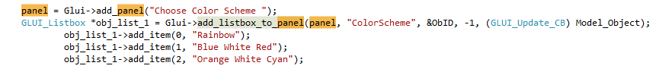

1. Write a call-back function that chooses the respective colour schemes when they are selected at the interface.

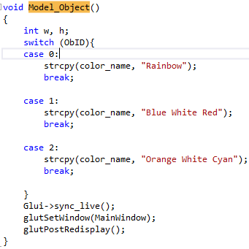

1. The Smin and Smax values are also calculated for each model (each .ply file) separately as the file is selected and loaded.

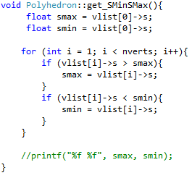

1. For **Rainbow** ColorScheme :
2. Calculate the Minimum and Maximum values of ‘S’ . (The value of S is taken from the .ply file)
3. Use the following formula for Hue:

Hue = 240 – 240*((S-SMin)/(SMax-SMin))

1. The Saturation, Value are 1.0.
2. Convert to RGB values using HsvRgb() method

.

For **Divergent** Red White Blue ColorScheme

1. Calculate Minimum and Maximum Values of S.
2. Calculate the average of the Max and Min values
3. If vertices are less than average the make Hue = 240

Saturation = ((Average - S)/(Average - SMin))

1. If vertices are more than the average then make Hue = 0

Saturation = ((S – Average)/(Smax – Average))

1. Set the value to 1.
2. Convert to RGB values using HsvRgb() method.

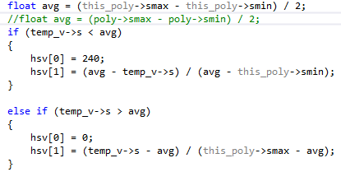

For **OrangeWhite Cyan Color Scheme**

1. It is similar to the divergent method but set the Hue values to a different range.
2. We can also get various other schemes according to the hues we set.

Data – Few Samples

1. Diesel Field - Rainbow

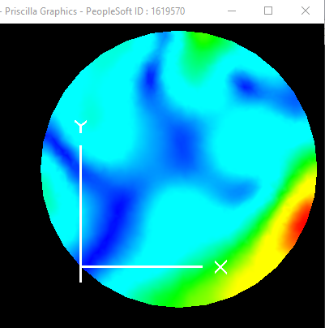

1. Torus Field - Rainbow

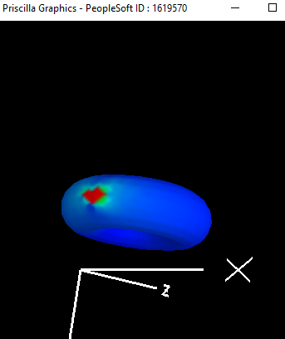

1. Distance Field 2 – Blue White Red

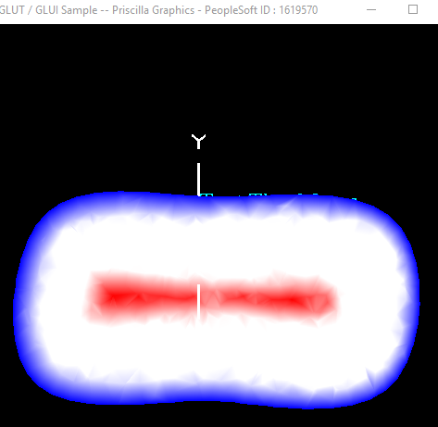

1. Torus Field – Orange White Cyan

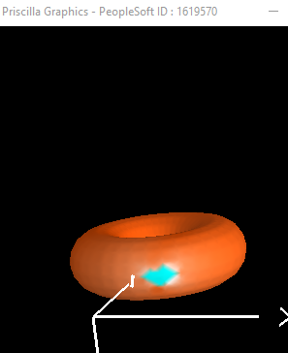

Task – 3

1. If we observe most of the values on the torus have the same color, so that is where the dynamic range issue occurs. And there is huge disparity is the data values.
2. The smin is 0.000363 and smax is 1. And if all the pixel values in the torus dataset are plotted then most of the values to map to “Blue” Color and very few to the other colors.
3. To reduce this effect we can normalize the values and set the maximum value to a lower value .
4. On writing our own transfer function using a manually computed SMax value.

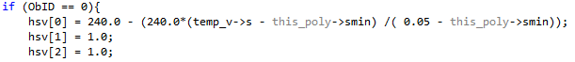

Rainbow

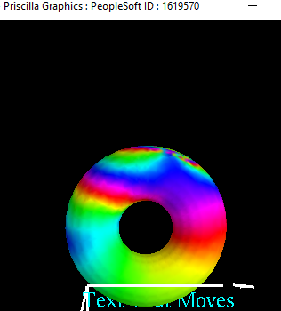

Blue-White-Red

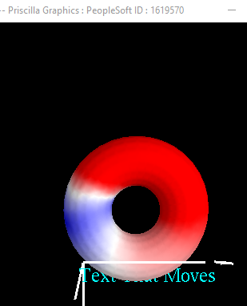

Orange – White – Cyan

